Summative assessment – Questions

Variables in games

Q1. Which of these are important features of a variable? Tick all that apply.

- Can be set
- Is a score
- Can be changed
- Has a clear name

Q2. Which data types can a variable hold?

- Numbers only
- Letters only
- Numbers or letters
- Pictures

Q3. How many values can a variable hold at any one time?

- None
- One
- Two
- Three

Q4. When a variable is changed, what happens to the value?

- It is replaced by a new value
- It is joined by the new value
- It is added to the new value

Q5. In a bat and ball game, which of these parts of the game could be stored using a variable? Tick all that apply.

- Points scored
- Movement of the sprite
- Lives lost
- Time left
- Appearance of the Stage

Q6. Imagine that you are storing the score of a football match using a computer program to display to the crowd during the game. Which name would be the best choice for the variable that holds the score of the home team?

- Home score
- Home_score
- Football_match_home_team_score
- Score

Q7. Where is the value of a variable usually set?

- At the beginning of a program
- Throughout the running of a program
- At the end of a program
- When triggered by an event

Q8. Which of the following code snippets would create a timer that counts down from 60 seconds to 0?

A.  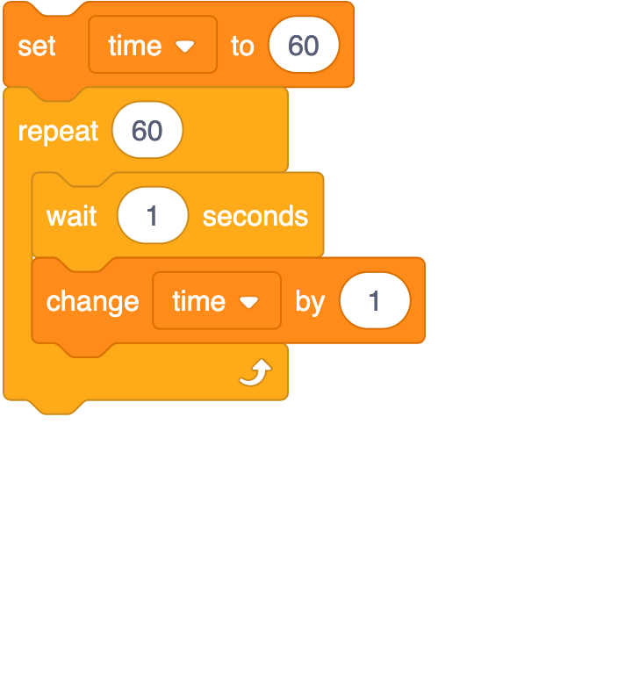 | B.  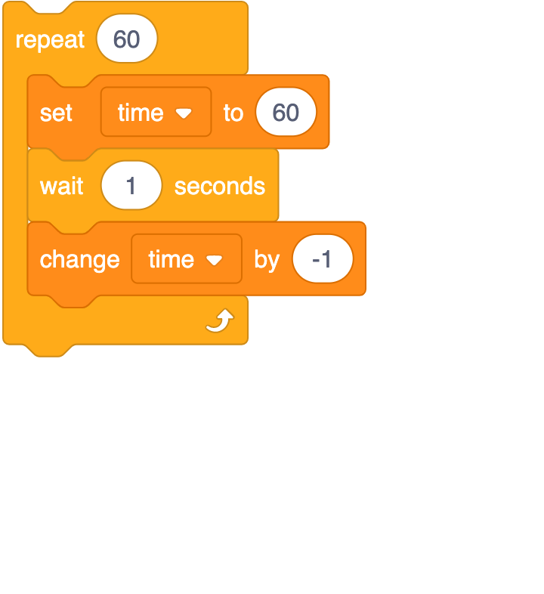
C.  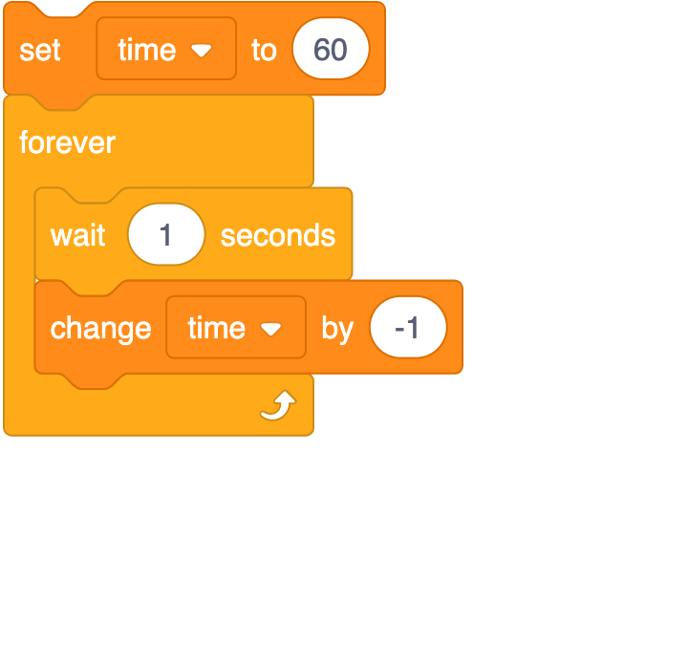 | D.  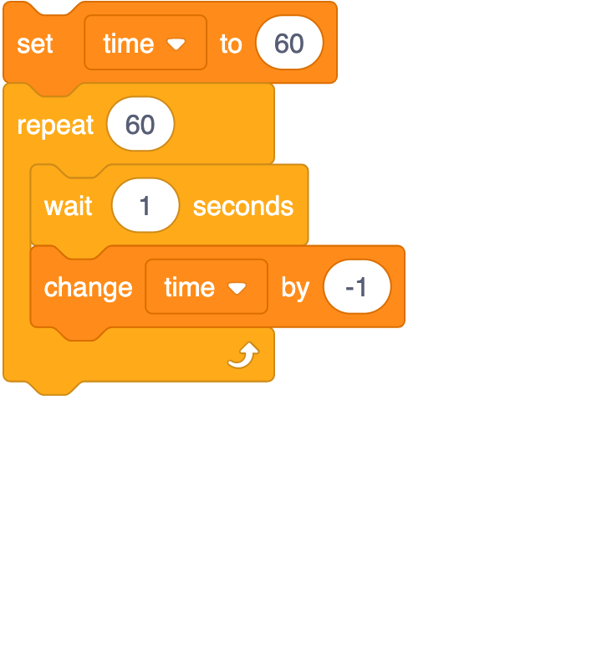

Q9. The code snippet below controls the movement of a ball in a game in the style of table tennis. The Stage is also shown next to the code.

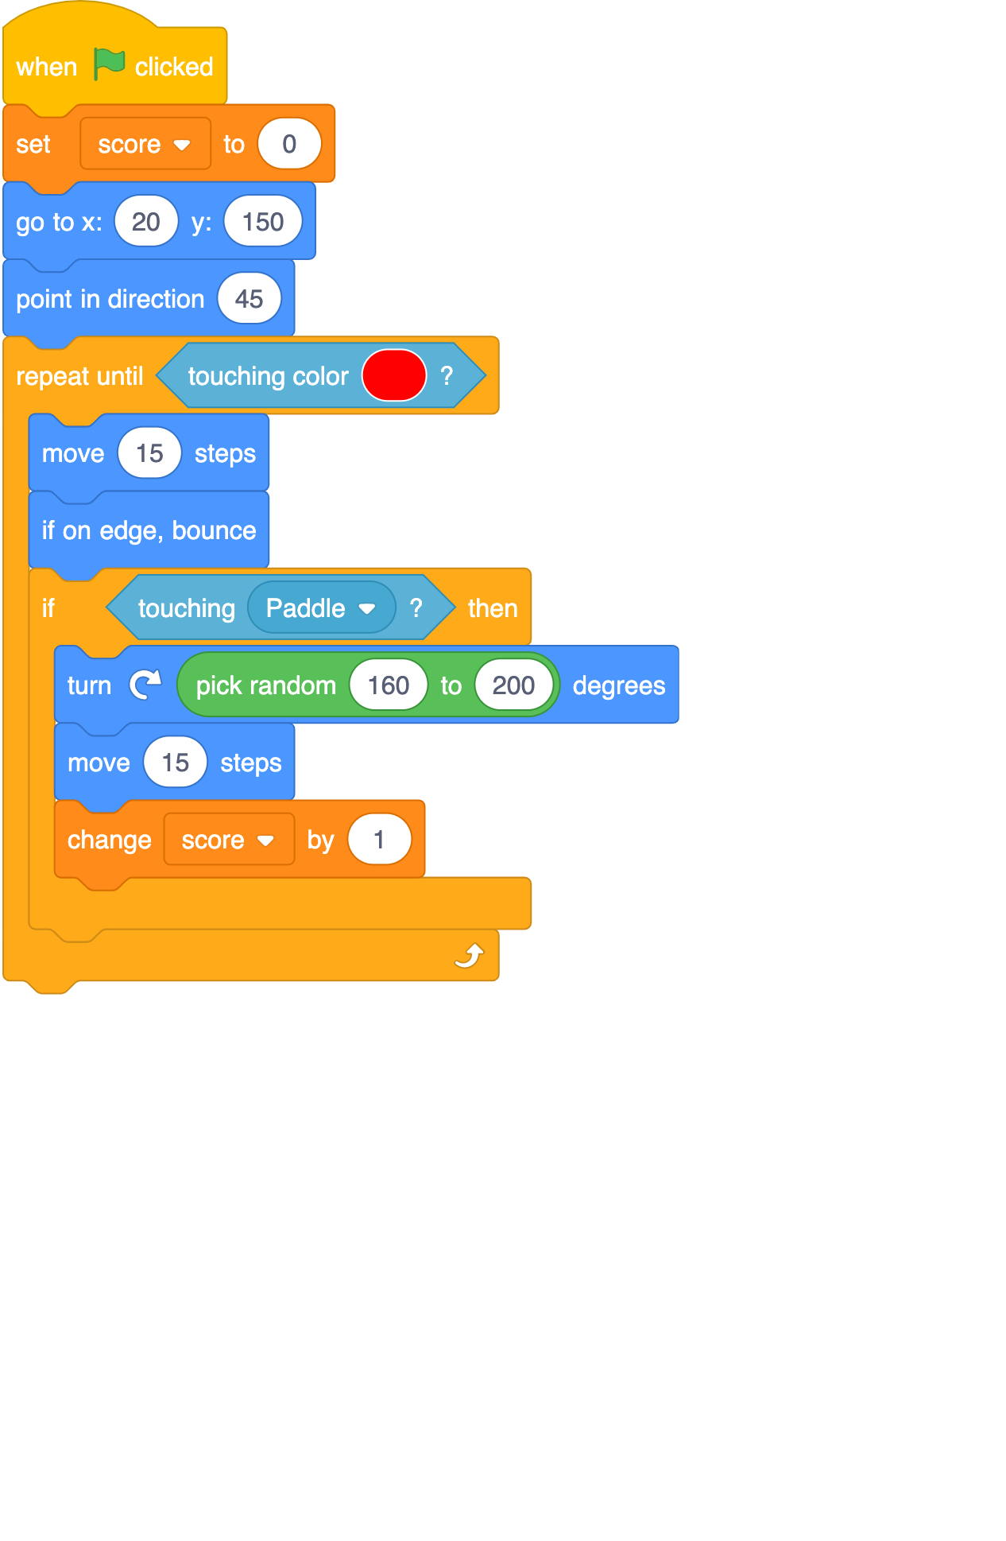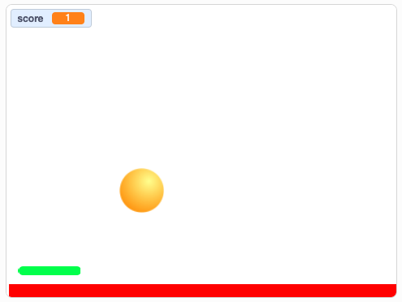

When will the score change?

- When the ball moves
- When the ball touches the paddle
- When the green flag is clicked
- When the ball hits the edge

Q10. What describes the order in which commands are run during a program?

- The algorithm
- The code
- The program flow
- The task

This resource was created by Raspberry Pi Foundation and updated by STEM Learning for the National Centre for Computing Education.

The contents of this resource are available for use under the Open Government License (OGL v3) meaning you can copy, adapt, distribute and publish the information. You must acknowledge the source of the Information in your product or application, by attributing Raspberry Pi Foundation and STEM Learning as stated here, and are asked to provide a link to the OGL v3.

The original version can be made available on request via info@teachcomputing.org.

Resources are updated regularly — the latest version is available at: ncce.io/tcc.

